PHASE 5 OF 8
Project Development Phase
Step-by-step build in ServiceNow, with screenshots

Project | Platform | Team
Auto Ticket Classification using Flow Designer | ServiceNow (Flow Designer) | SAMRIN HASRAA S  SALMA FARHANA M  SAJITHA FATHIMA S K  FATHIMA M

Milestone 1 – Update Set

Activity 1: Create a new Update Set
- Go to All → Local Update Sets (under *System Update Sets*).
- Click New and enter Name: Project Update Set, State: In progress, Application: Global.
- Save the form.
- Under *Related Links* click Make This My Current Set. The update set now appears as current, so every change is captured in it.
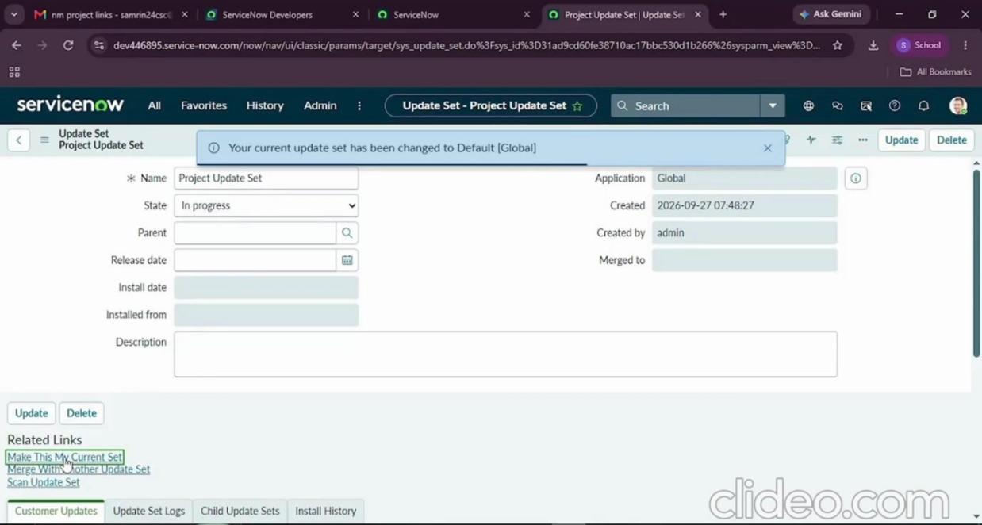
Figure 5.1 – Project Update Set created and set as current

Milestone 2 – Backend Development & Configuration

Activity 1: Create the custom table Incident Workflow
- Go to All → Tables (under *System Definition*).
- Click New and enter Label: Incident WorkFlow (table name becomes u_incident_workflow). Uncheck Create module.
- Open the Controls tab and enable Auto Number (prefix INC).
- Save the form.
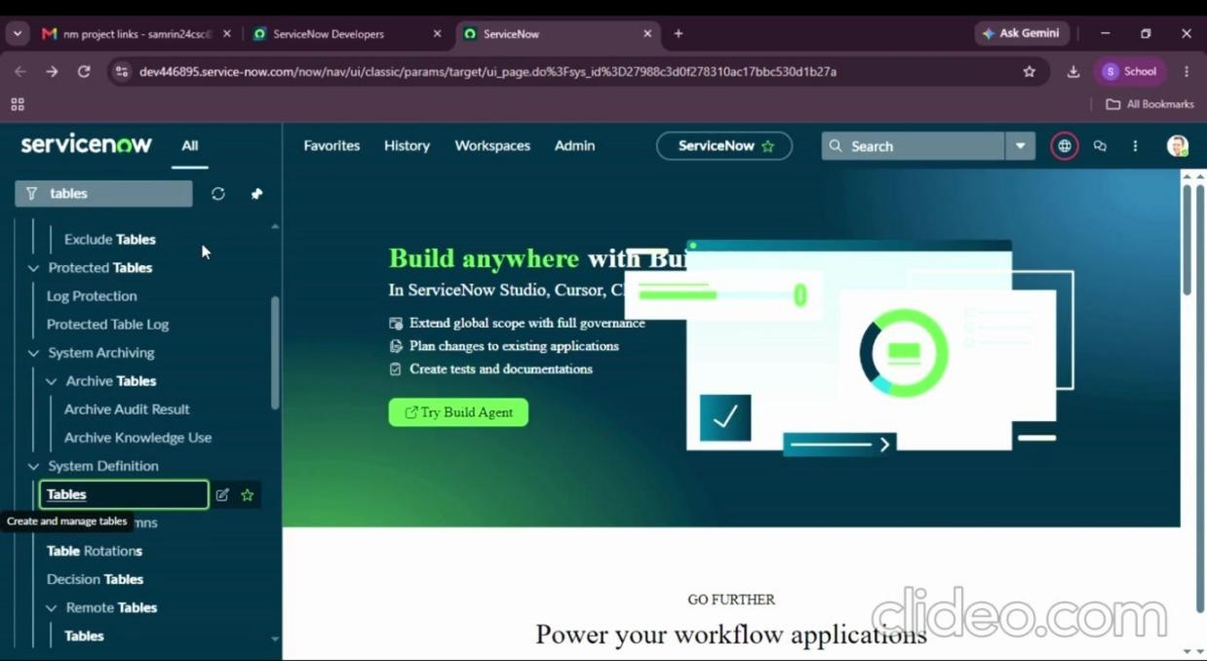
Figure 5.2 – Opening the Tables module
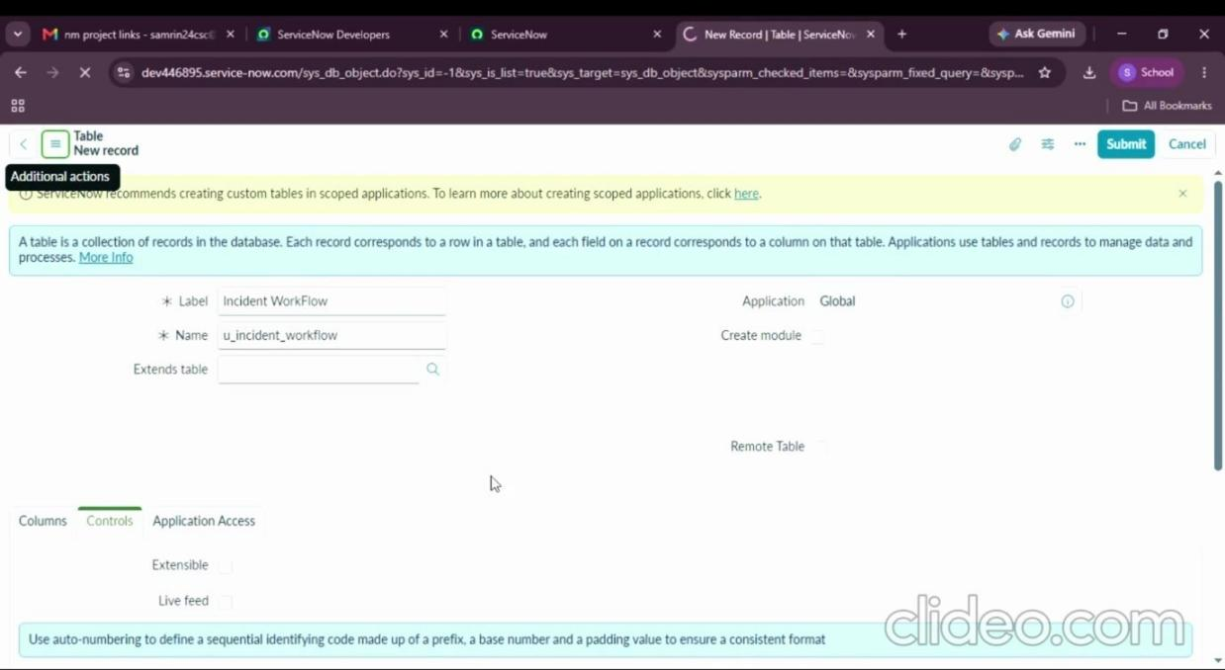
Figure 5.3 – New table with label Incident WorkFlow
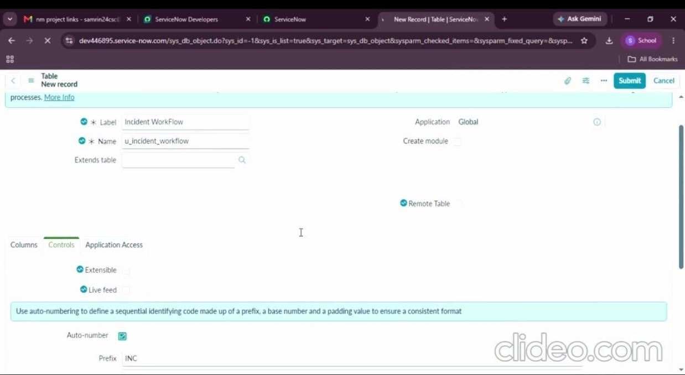
Figure 5.4 – Auto Number enabled with prefix INC

Activity 2: Create fields using Form Designer
Under *Related Links* click Show Form, then open Configure → Form Designer. Add the fields below by dragging field types into the form and editing their *Properties*.
Field Label | Type | Reference / Choices
Number | Auto Number | –
Caller | Reference | sys_user
Category | Choice | Network, Hardware, Access, Performance
Subcategory | Choice | Wi-Fi, Projector, Forgot Password, Slow Computer
Short Description | String | –
Description | String | –
State | Choice | New, In progress, On hold, Resolved, Closed
Assigned Group | Reference | sys_user_group
Assigned to | Reference | sys_user

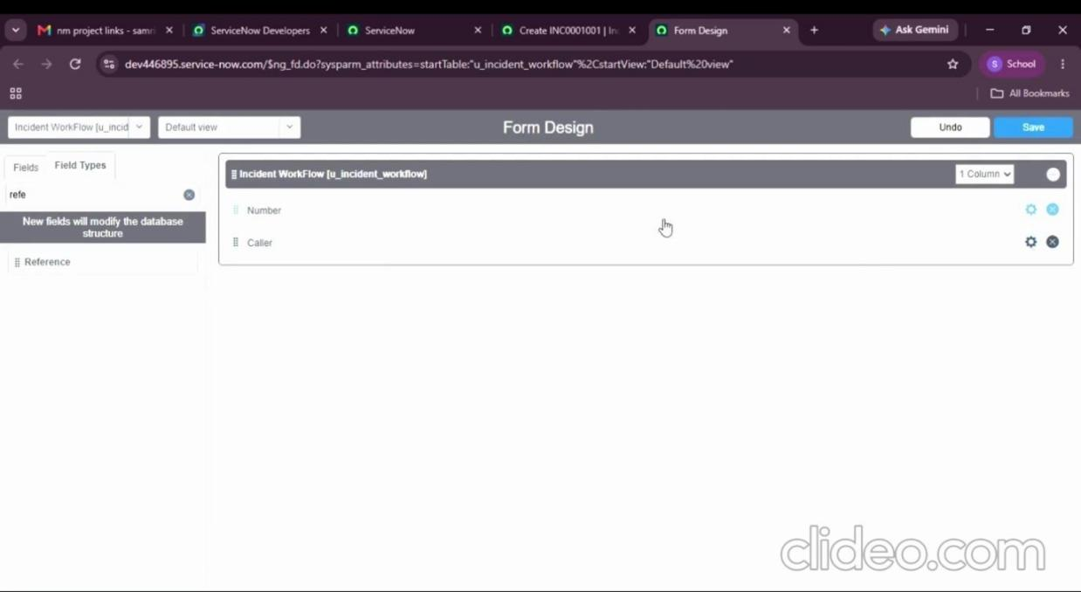
Figure 5.5 – Form Designer with the first fields added
Add choices to the three choice fields (Category, Subcategory and State):
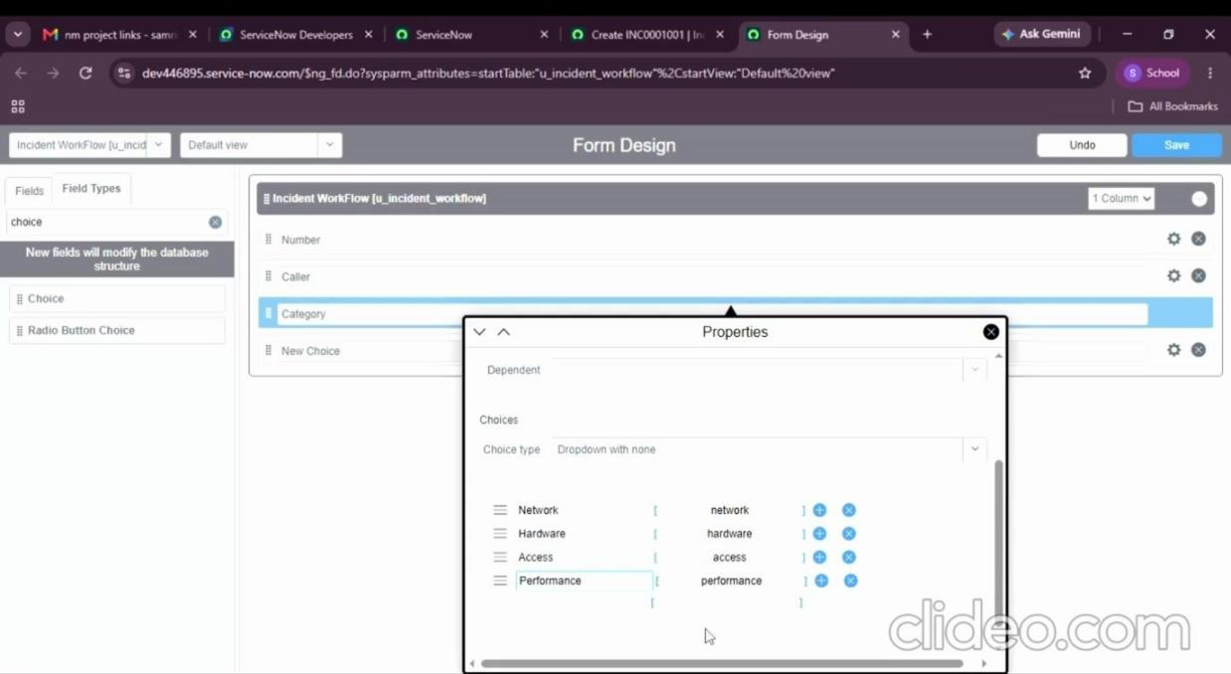
Figure 5.6 – Category choices
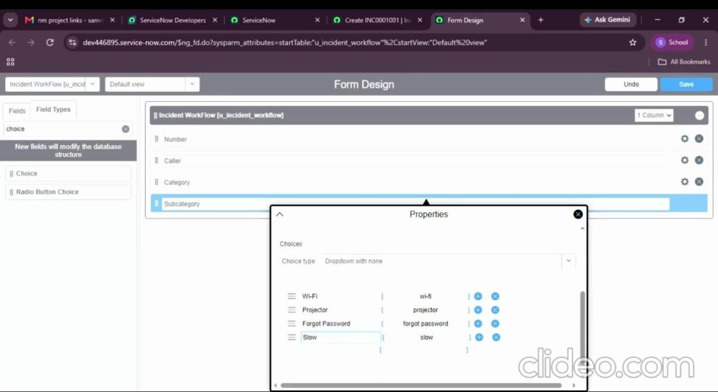
Figure 5.7 – Subcategory choices
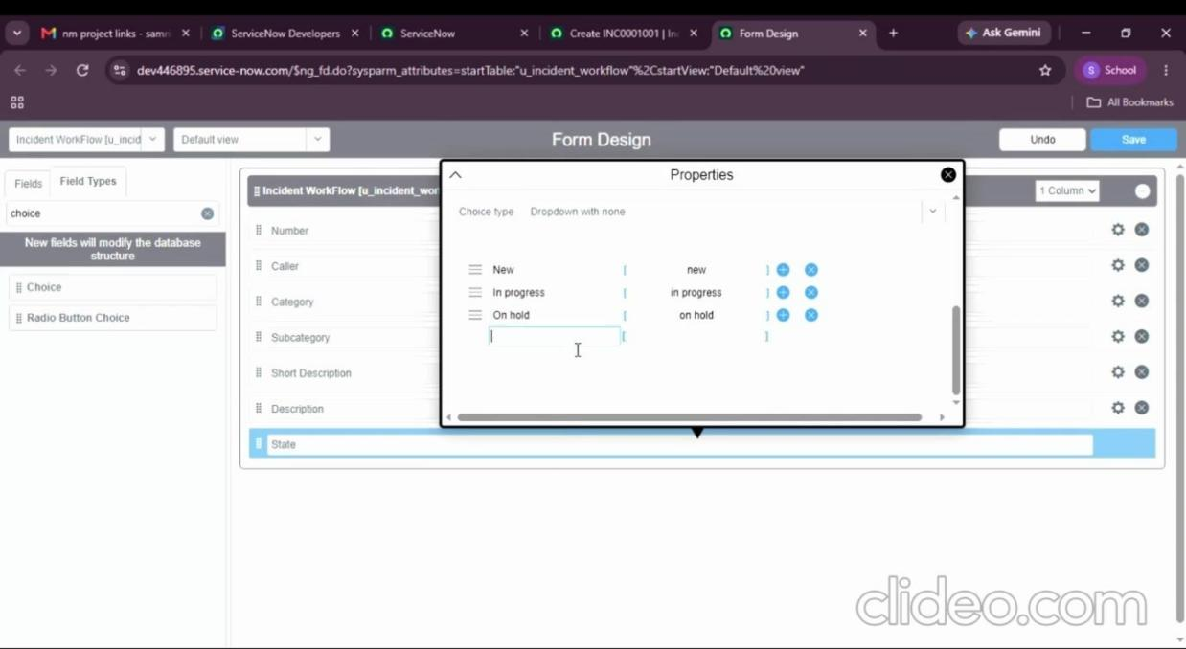
Figure 5.8 – State choices
Reference fields (Caller, Assigned Group and Assigned to) point to sys_user or sys_user_group:
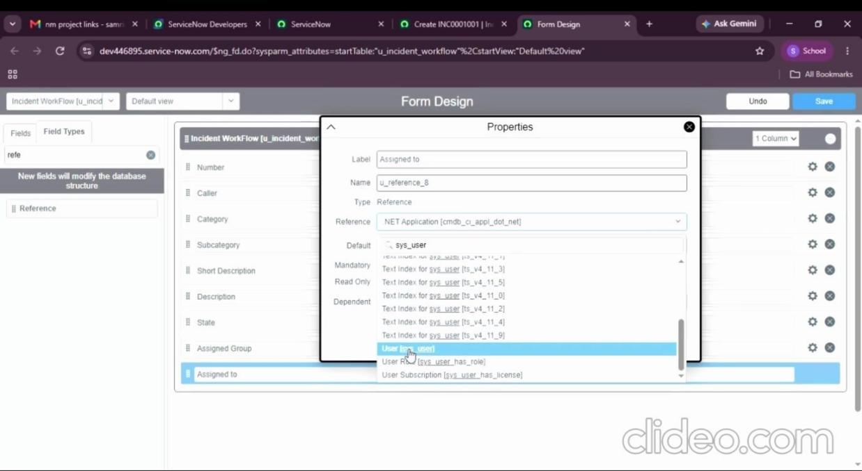
Figure 5.9 – Assigned to reference field pointing to User table
Click Save in Form Designer and reload the form. The final list of table columns:
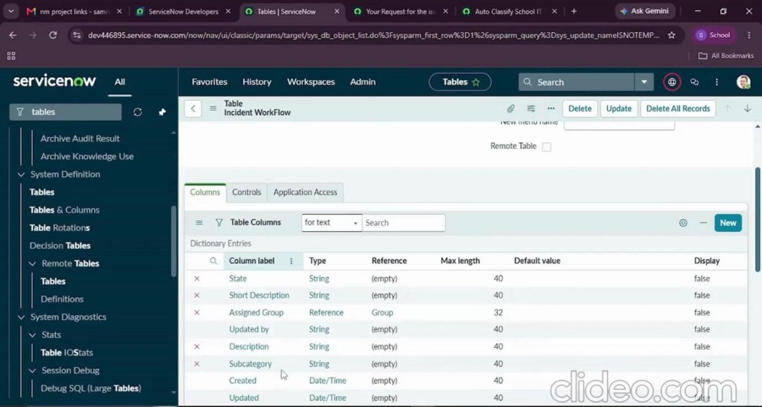
Figure 5.10 – Table columns after saving

Activity 3: Dependency between Category and Subcategory
- Open the table form, right-click the Subcategory label and choose Configure Dictionary.
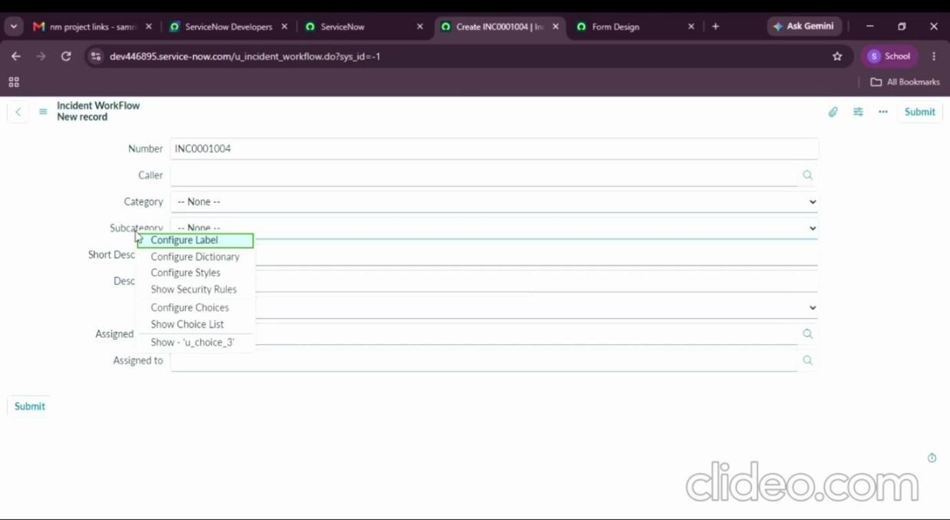
Figure 5.11 – Configure Dictionary on Subcategory
- Under *Related Links* click Advanced view and open the Dependent Field tab.
- Tick Use dependent field and select Category in *Dependent on field*. Save.
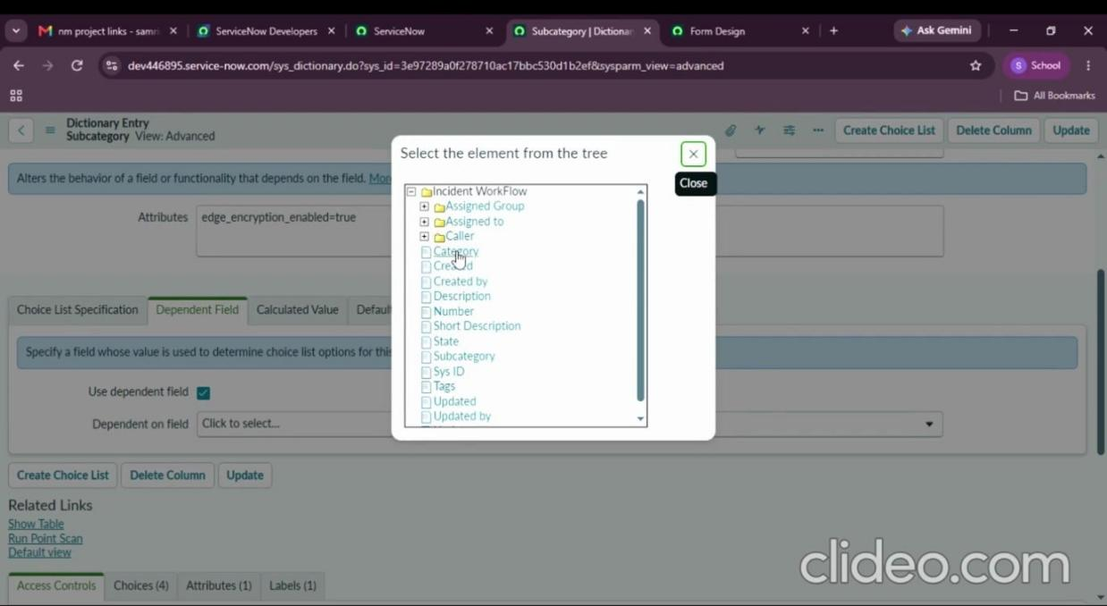
Figure 5.12 – Use dependent field enabled
Scroll to the Choices related list and fill the *Dependent value* of each Subcategory choice with its Category:
Subcategory | Dependent value (Category)
Wi-Fi | Network
Projector | Hardware
Forgot Password | Access
Slow Computer | Performance

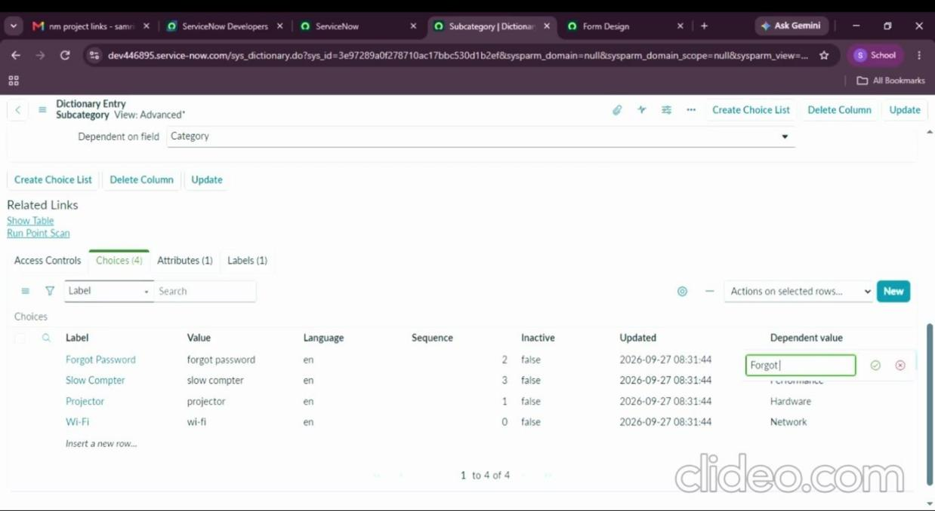
Figure 5.13 – Dependent values on Subcategory choices
Now, after choosing a Category, only its matching Subcategory is displayed.

Milestone 3 – Automation using Flow Designer & Email
When a student creates a ticket they only enter Caller and Short Description. The flow reads the description, assigns Category and Subcategory, and emails the caller.

Activity 1: Create the flow
- Go to All → Flow Designer (under *Process Automation*).
- Click New → Flow.
- Flow name: Auto Classify School IT Tickets, Application: Global, then Build Flow.

Activity 2: Trigger configuration
- Trigger: Record → Created
- Table: Incident Workflow
- Condition: Category is empty
- Click Done, then under Actions choose Flow Logic.
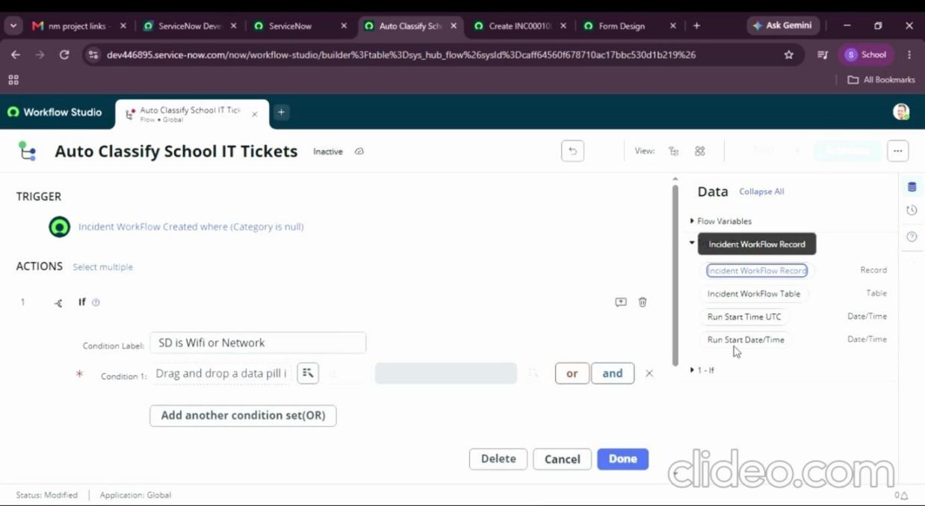
Figure 5.14 – Flow trigger and the first If block

Activity 3: Wi-Fi issue classification
- Add an If block with Condition label SD is Wifi or Network.
- Condition 1: Short description → contains → Wi-Fi.
- Add an OR condition: Short description → contains → Network. Click Done.
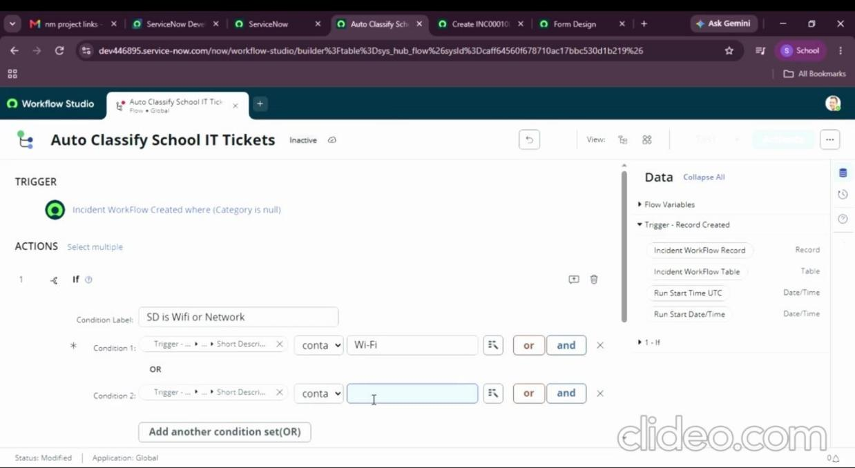
Figure 5.15 – Wi-Fi OR Network conditions
- Add the action Update Record, table Incident Workflow, and set Category = Network and Subcategory = Wi-Fi. Click Done.
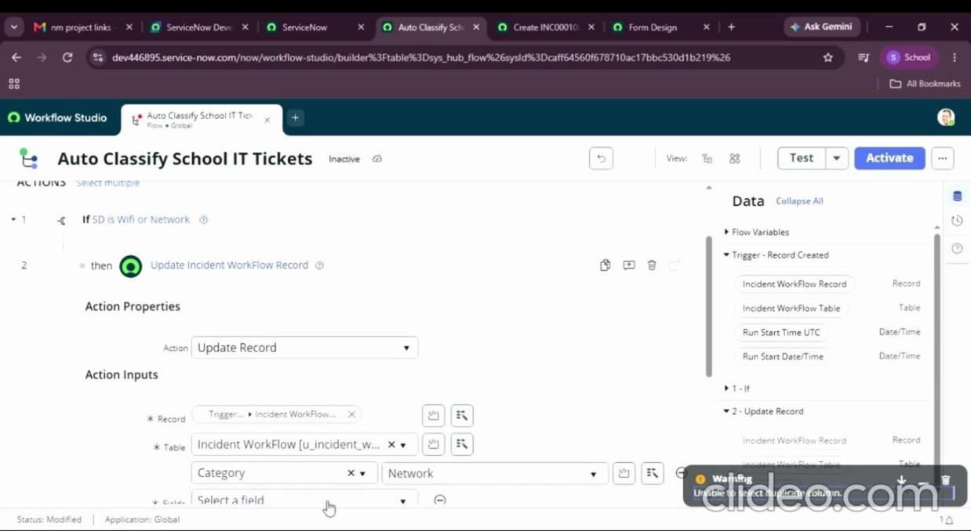
Figure 5.16 – Update Record for the Wi-Fi branch

Activity 4: Projector issue classification
- Add Else If with label SD is Projector or Hardware, condition Short description contains Projector.
- Add Update Record: Category = Hardware, Subcategory = Projector.
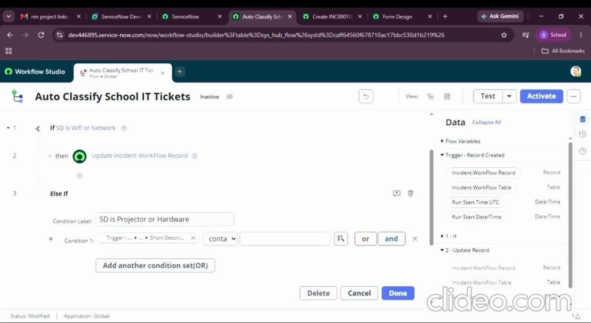
Figure 5.17 – Else If condition for Projector

Activity 5: Password issue classification
- Add Else If with label SD is Forgot password, condition Short description contains Forgot password.
- Add Update Record: Category = Access, Subcategory = Forgot Password.
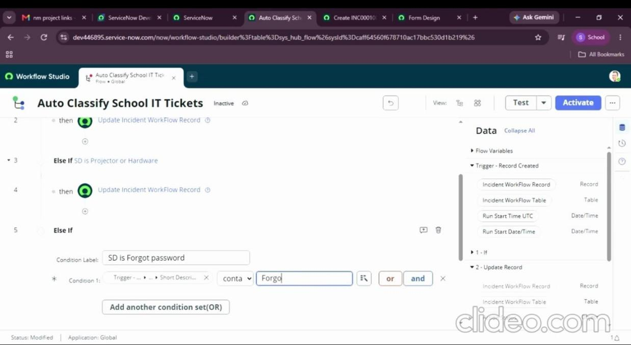
Figure 5.18 – Else If condition for Forgot password
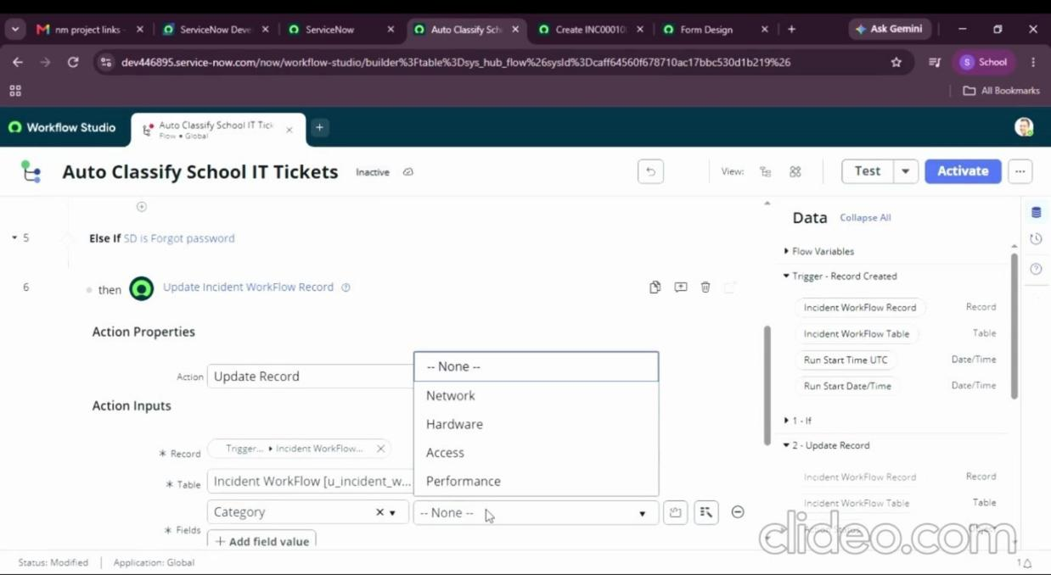
Figure 5.19 – Choosing the Category value in Update Record

Activity 6: Slow computer classification
- Add Else If with label SD is Performance, condition Short description contains Slow Computer.
- Add Update Record: Category = Performance, Subcategory = Slow Computer.
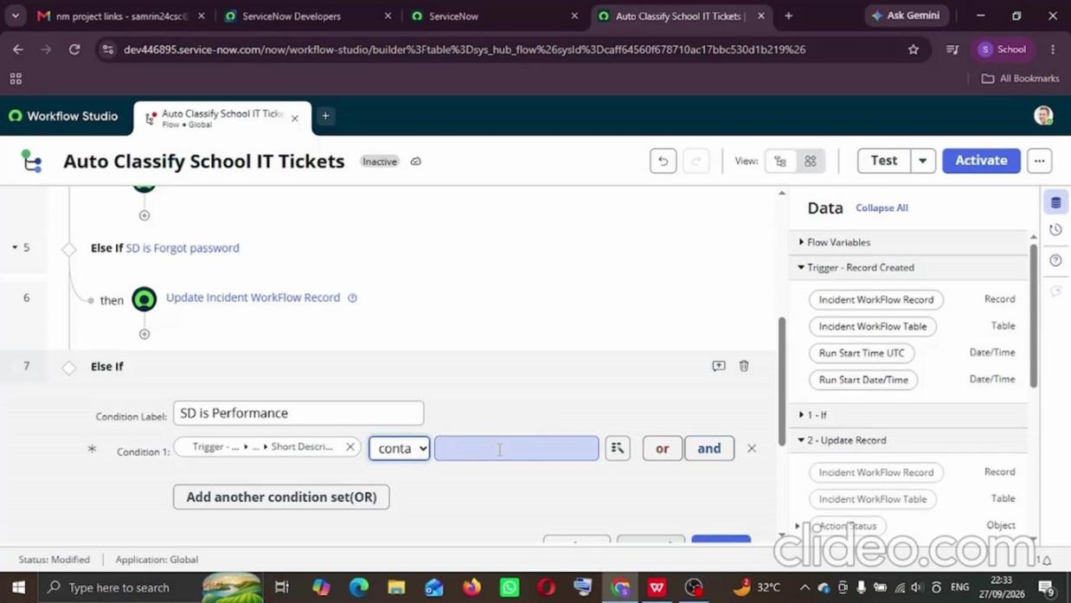
Figure 5.20 – Else If condition for Slow Computer
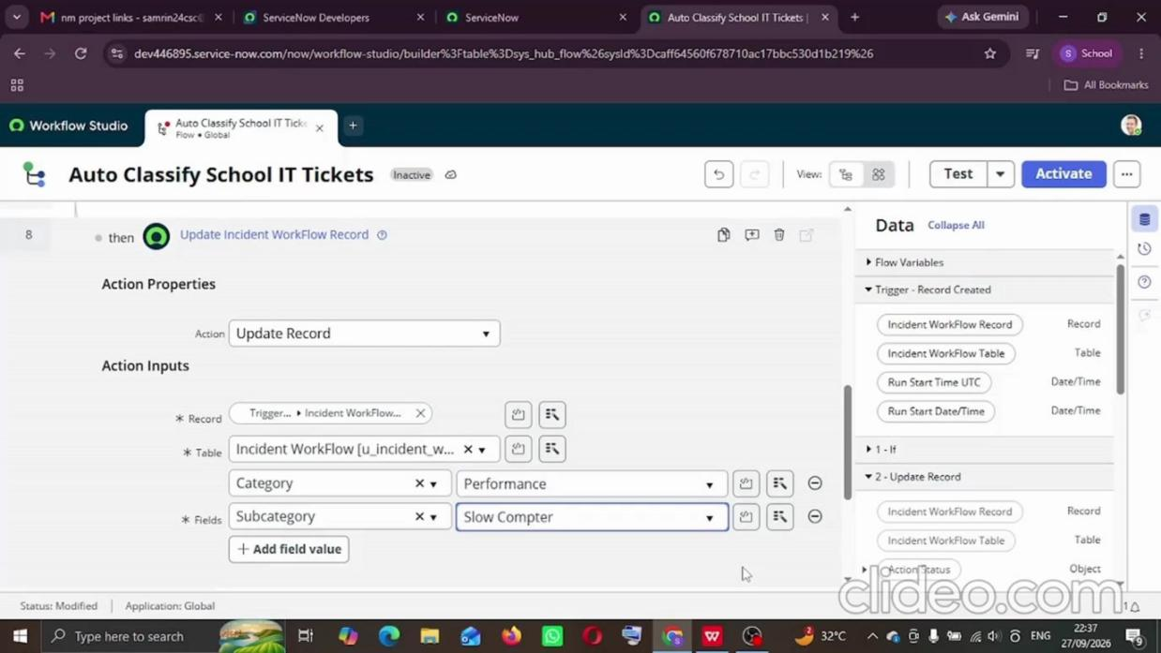
Figure 5.21 – Update Record for the Slow Computer branch

Activity 7: Email action setup
- After the classification branches add the action Send Email.
- To: Caller → Email (data pill).
- Subject: Your Request for the issue has been submitted.
- Body: ticket confirmation message.
- Click Done, then Save and Activate the flow (top right).
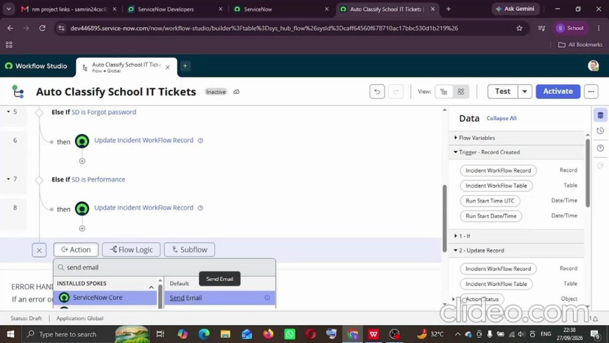
Figure 5.22 – Adding the Send Email action

What the Update Set captured
Component | Details
Table | Incident Workflow (u_incident_workflow)
Dictionary entries | Number, Caller, Category, Subcategory, Short Description, Description, State, Assigned Group, Assigned to
Dependency | Subcategory dependent on Category
Choices | Choice-list records for Category, Subcategory and State
Auto-numbering | Number record with prefix INC
Security | Role u_incident_workflow_user and default ACLs (create, read, write, delete)
Flow | Auto Classify School IT Tickets (auto_classify_school_it_tickets) – active

Result of development
- Custom table with auto-numbered records
- Dependent Category → Subcategory choices
- Flow with four classification branches
- Confirmation email to the caller
- Everything tracked in one Update Set

